**Student Name: *ISHITA SHRIVASTAVA***

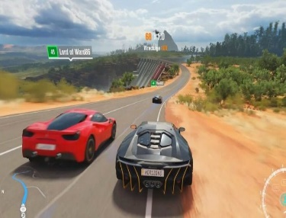



CAR RACING GAME

***TISHA KUSHWAH***

**Student Regd. No and Batch: *E23CSEU2190***

***E23CSEU2188***

***BATCH NO. – 73***

**Course: *CSET101- Computational Thinking and Programming***

**Lab Instructor: *MS. SHIVANI TUFCHI***

**Submission Date: *24.11.2023***

**Abstract**

(Provide a brief summary of the project, including the problem statement, methodology, and key findings.)

**Project Summary: Car Racing Game**

**Problem Statement:** The project aims to create a simple car racing game using the Pygame library in Python. The main challenge is to implement a playable game with user-controlled car movement, obstacles (enemy cars), scoring, and collision detection.



**Methodology**

1. **Initialization:** The Pygame library is utilized to set up the game environment, including the display window and necessary components.
2. **Game Loop:** The core functionality is implemented within a game loop. User input is captured for left and right movement of the player's car..
3. **Collision Detection:** The game checks for collisions between the player's car and the enemy cars. If a collision occurs, the game ends, and a game-over message is displayed.

**Conclusion:** The car racing game project successfully implements a playable game with user interaction, scoring, and dynamic difficulty. It serves as a foundation for further enhancements and modifications to create a more feature-rich and visually appealing gaming experience.

1.(Explain the background information and context of the project.)

Top of Form

Bottom of Form

**1.1 Background Information and Context of the Car Racing Game Project:**

1. Motivation.

2. Programming Language and Library Choice.

3. Target Audience.Top of Form

**1.2 Problem Statement**

(Clearly define the problem that your project addresses.)

**Problem Statement:**

The Car Racing Game project addresses the need for a simple, yet engaging, game that can serve as a practical introduction to basic game development concepts using Python and Pygame. The problem it aims to solve can be broken down into several key aspects:

1. Entry-Level Game Development.
2. Hands-On Learning Experience.
3. Introduction to Pygame..

By addressing these aspects, the Car Racing Game project aims to break down barriers for individuals interested in exploring game development, offering them a starting point for building more complex games and fostering a greater understanding of programming and interactive software development.

**1.3 Objectives**

(List the objectives and goals of your project.)

**Objectives and Goals of the Car Racing Game Project:**

1.Gameplay Experience.

2. Scoring System.

3. Graphics

4.HighScore Tracking.

**2.1 Tools and Technologies Used**

(Describe the programming tools, libraries, and technologies used in the project.)

**Programming Tools, Libraries, and Technologies Used in the Car Racing Game Project:**

**1.Pygame Library:**

* + **Description:** Pygame is a set of Python modules designed for game development. It provides functionalities for handling graphics, user input, sound, and more.
  + **Purpose:** Pygame simplifies the process of game development, allowing developers to focus on the game's logic and design rather than low-level graphics and input handling.

**2.Random Module (Standard Library):**

* + **Description:** The random module in the Python standard library is used to generate random numbers.
  + **Purpose:** Random numbers are employed to determine the starting position of enemy cars, introducing variability in the game.

**3.Time Module (Standard Library):**

* + **Description:** The time module in the Python standard library is used for introducing delays.
  + **Purpose:** Delays are used for a smoother gaming experience, particularly when displaying messages or restarting the game.

**2.2 Project Design**

(Explain the design of your project, including data flow, algorithms, and architectural design.)

**Design of the Car Racing Game Project:**

1. Data Flow.

2. Algorithms.

3. Architectural Design. Top of Form



Bottom of Form

**Results and Discussion**

**3.1 Project Outcomes**

(Present the outcomes of the project, including any data analysis or user interface.)

1. Gameplay experience.
2. Scrolling system.
3. Collision detection.  
   1. **Challenges Faced**
4. (Discuss any challenges encountered during the project and how they were overcome.)

* **Pygame Installation and Setup:**
  + **Challenge:** Setting up Pygame and ensuring it works correctly on different platforms can be challenging for beginners.
  + **Solution:** Provide clear installation instructions and troubleshoot common issues. Consider using virtual environments to manage dependencies.
* **Collision Detection Accuracy:**
  + **Challenge:** Ensuring accurate collision detection between the player's car and enemy cars can be tricky.
  + **Solution:** Use bounding boxes or circles for collision detection. Test and adjust collision logic to ensure fairness and avoid false positives or negatives.

These challenges are common in game development projects, and overcoming them often involves a combination of research, experimentation, and persistence. Regular testing, seeking feedback, and incremental development can contribute to a successful and enjoyable game development experience.

Top of Form

**3.3 Learnings and Insights**

(Share the learnings and insights gained from working on the project.)

1. **Practical Application of Programming Concepts:**
   * Developing a game allows for the practical application of programming concepts, including loops, conditional statements, functions, and event-driven programming.
2. **Understanding Game Development Workflow:**
   * Learning how to structure a game project, manage game loops, handle user input, and implement features contributes to an understanding of the game development workflow.
3. **Object-Oriented Design Principles:**
   * Implementing classes and objects in the context of a game project reinforces object-oriented design principles. This includes encapsulation, inheritance, and abstraction.

**Conclusion**

(Summarize the project, its impact, and potential future work or improvements.)

**Project Summary:**

The Car Racing Game project is a Python-based game developed using the Pygame library. It provides a simple and engaging gameplay experience where players control a car, avoiding collisions with randomly generated enemy cars while navigating a scrolling background. The game incorporates fundamental game development concepts, including event-driven programming, collision detection, and dynamic difficulty adjustment.

**Impact:**



1. Educational Value.
2. Skill Development.
3. Problem-Solving and Debugging.
4. Creativity and Design**.**

**Potential Future Work or Improvements:**

1. Additional Features.
2. Enhanced Graphics and Sound.
3. Advanced Difficulty Scaling.
4. Optimization and Performance..
5. User Interface Refinement..

By addressing these areas, developers can elevate the project to a more advanced and feature-rich game, contributing to continuous learning and skill development in game development and software engineering.

Top of Form

**References**



(List any references, sources, or external materials used in the project.)

Geeksforgeeks - <https://www.geeksforgeeks.org/>

Google: <https://www.google.com/>

Book References:

* Sumita Arora class11
* Sumita Arora class12

Youtube:-

<https://www.youtube.com/@gauravkumarjain>

Appendices

(Include any additional material such as code snippets, screenshots, or diagrams.)

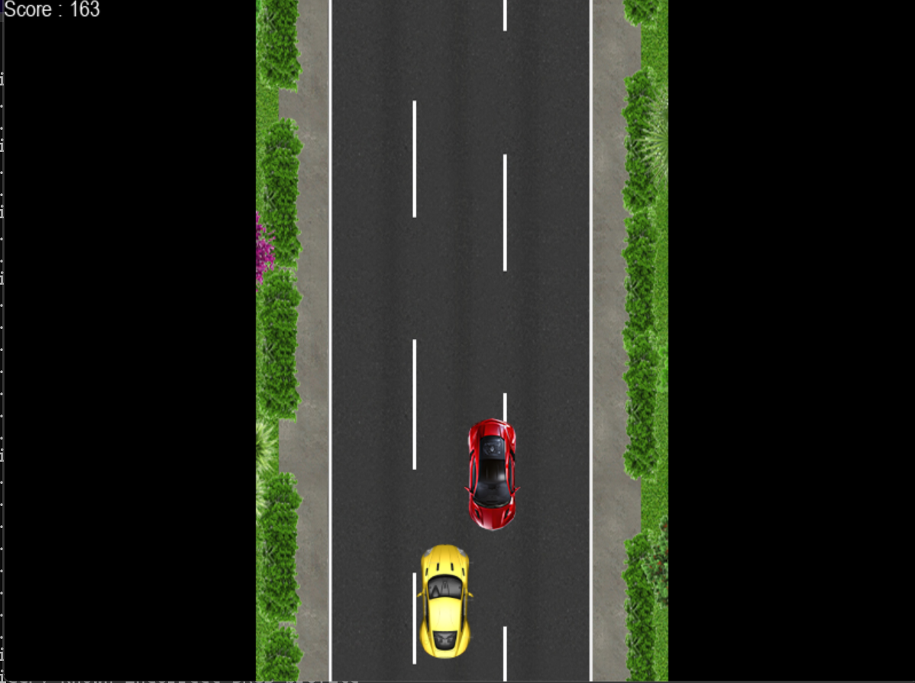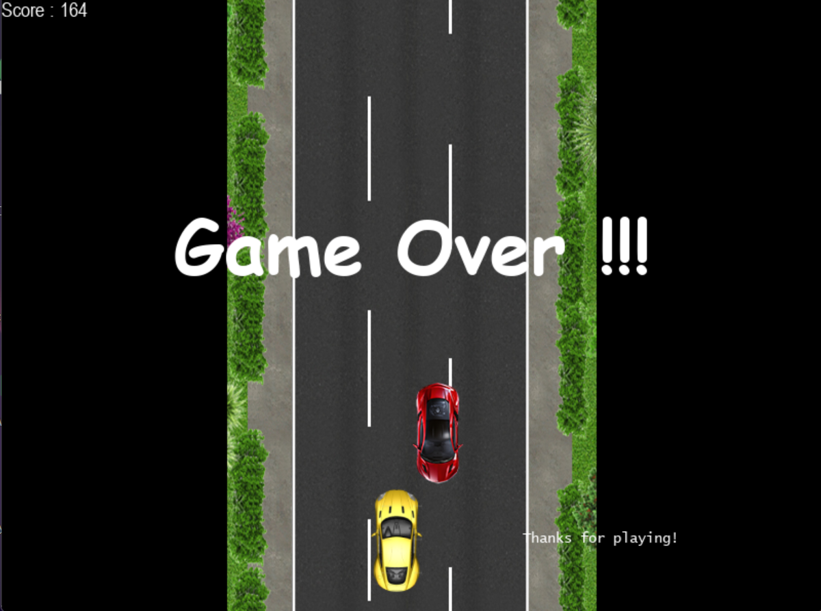

This template provides a comprehensive structure for your Python project report. Remember to keep the language clear and concise, and ensure that all technical aspects of the project are thoroughly explained.